North-South Comparisons
Personal income per capita by region as a percentage of US average
 | 1840 | 1860
Northeast | 135 | 139
West | 68 | 68
South | 76 | 72

Personal Income per capita by region as a percentage of US average
 | North | South
Proportion of nation’s population | 71 | 29
Proportion of nation’s
white population | 79 | 21
black population | 13 | 87
Proportion of nation’s railroads | 71 | 29
Proportion of nation’s farm acreage | 65 | 35
Proportion of nation’s manufacturing workers | 92 | 8
Proportion of nation’s manufacturing output | 92 | 8
Number of factories | 110,000 | 18,000
Railroad mileage | 22,000 | 9,000

Nathaniel P. Banks
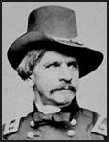 | Home State |  | West Point Graduate? |  |  | Year of Graduation |  |  | Class Rank |  |  | Age in 1861 |  |  |  | Previous Military Experience
 | Massachusetts |  | N |  |  | N/A |  |  | N/A |  |  | 45 |  |  |  | None

Don Carlos Buell
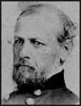 | Home State | West Point Graduate? |  |  | Year of Graduation |  |  | Class Rank |  |  | Age in 1861 |  |  | Previous Military Experience
 | Ohio | Y |  |  | 1841 |  |  | 32 |  |  | 43 |  |  | Mexican War  (1846-48)

Ambrose B. Burnside
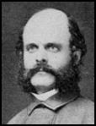 | Home State | West Point Graduate? |  |  | Year of Graduation |  |  | Class Rank |  |  | Age in 1861 |  |  | Previous Military Experience
 | Indiana | Y |  |  | 1847 |  |  | 18 |  |  | 37 |  |  | Mexican War  (1846-48)

Benjamin F. Butler
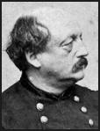 | Home State |  |  | West Point Graduate? |  |  | Year of Graduation |  |  | Class Rank |  |  | Age in 1861 |  | Previous Military Experience
 | New Hampshire |  |  | N |  |  | N/A |  |  | N/A |  |  | 47 |  | None

Samuel R. Curtis
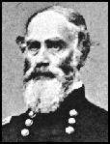 | Home State | West Point Graduate? |  |  | Year of Graduation |  | Class Rank |  | Age in 1861 |  | Previous Military Experience
 | New York | Y |  |  | 1831 |  | 27 |  | 45 |  | Mexican War  (1846-48)

John C. Fremont
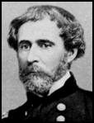 | Home State |  | West Point Graduate? |  | Year of Graduation |  | Class Rank |  | Age in 1861 |  |  | Previous Military Experience
 | Georgia |  | N |  | N/A |  | N/A |  | 48 |  |  | None

Ulysses S. Grant
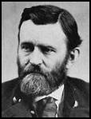 | Home State |  | West Point Graduate? |  | Year of Graduation |  | Class Rank |  | Age in 1861 |  |  | Previous Military Experience
 | Ohio |  | Y |  | 1843 |  | 21 |  | 39 |  |  | Mexican War  (1846-48)

George B. McClellan
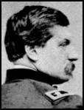 | Home State |  |  | West Point Graduate? |  | Year of Graduation |  | Class Rank |  | Age in 1861 |  |  | Previous Military Experience
 | Pennsylvania |  |  | Y |  | 1846 |  | 2 |  | 35 |  |  | Mexican War  (1846-48)

John Pope
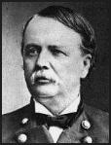 | Home State |  | West Point Graduate? |  | Year of Graduation |  | Class Rank |  | Age in 1861 |  |  | Previous Military Experience
 | Kentucky |  | Y |  | 1842 |  | 17 |  | 39 |  |  | Mexican War  (1846-48)

Thomas J. Jackson
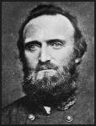 | Home State |  |  | West Point Graduate? |  |  |  | Year of Graduation |  |  |  | Class Rank |  |  |  | Age in 1861 |  |  |  | Previous Military Experience
 | Virginia |  |  | Y |  |  |  | 1846 |  |  |  | 17 |  |  |  | 37 |  |  |  | Mexican War  (1846-48)

Braxton Bragg
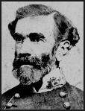 | Home State |  |  |  | West Point Graduate? |  |  |  | Year of Graduation |  |  |  | Class Rank |  |  |  | Age in 1861 |  |  |  | Previous Military Experience
 | North Carolina |  |  |  | Y |  |  |  | 1837 |  |  |  | 5 |  |  |  | 44 |  |  |  | Second Seminole War  (1835-42),  Mexican War  (1846-48)

P.G.T. Beauregard
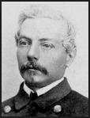 | Home State |  | West Point Graduate? |  |  |  | Year of Graduation |  |  |  | Class Rank |  |  |  | Age in 1861 |  |  |  | Previous Military Experience
 | Louisiana |  | Y |  |  |  | 1838 |  |  |  | 2 |  |  |  | 43 |  |  |  | Mexican War  (1846-48)

Albert S. Johnston
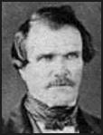 | Home State | West Point Graduate? |  |  |  | Year of Graduation |  |  |  | Class Rank |  |  |  | Age in 1861 |  |  |  | Previous Military Experience
 | Kentucky | Y |  |  |  | 1826 |  |  |  | 8 |  |  |  | 58 |  |  |  | Black Hawk War  (1832),  Texas War for Independence (1835-36),  Mexican War  (1846-48)

Joseph E. Johnston
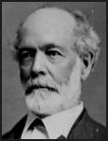 | Home State | West Point Graduate? |  |  |  |  | Year of Graduation |  |  | Class Rank |  |  | Age in 1861 |  | Previous Military Experience
 | Kentucky | Y |  |  |  |  | 1826 |  |  | 8 |  |  | 58 |  | Mexican War  (1846-48)

Robert E. Lee
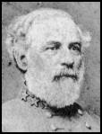 | Home State |  |  | West Point Graduate? |  |  | Year of Graduation |  |  | Class Rank |  |  | Age in 1861 |  |  |  | Previous Military Experience
 | Virginia |  |  | Y |  |  | 1829 |  |  | 2 |  |  | 54 |  |  |  | Mexican War  (1846-48)

John B. Magruder
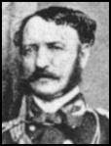 | Home State |  | West Point Graduate? |  |  | Year of Graduation |  |  | Class Rank |  |  | Age in 1861 |  |  |  | Previous Military Experience
 | Virginia |  | Y |  |  | 1830 |  |  | 15 |  |  | 54 |  |  |  | Second Seminole War  (1835-42),  Mexican War  (1846-48)

Earl C. Pemberton
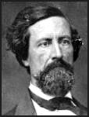 | Home State |  |  |  | West Point Graduate? |  |  | Year of Graduation |  |  | Class Rank |  |  | Age in 1861 |  |  |  | Previous Military Experience
 | Pennsylvania |  |  |  | Y |  |  | 1837 |  |  | 27 |  |  | 47 |  |  |  | Mexican War  (1846-48)

Strategic Objectives Readings

President Abraham Lincoln’s Proclamation Calling Militia and Convening Congress, April 15, 1861:
Whereas the laws of the United States have been for some time past, and now are opposed, and the execution thereof obstructed, in the States of the South Caroline, Georgia, Alabama, Florida, Mississippi, Louisiana and Texas, by combinations too powerful to be suppressed by the ordinary course of judicial proceedings, or by the powers vested in the Marshals by law,
Now therefore, I, Abraham Lincoln, President of the United States, in virtue of the power in me vested by the Constitution, and the laws, have thought fit to call forth, and hereby do call forth, the militia of several States of the Union, to the aggregate number of seventy-five thousand, in order to suppress said combinations, and to cause the laws to be duly executed. The details, for this object, will be immediately communicated to the State authorities through the War Department.
I appeal to all loyal citizens to favor, facilitate and aid this effort to maintain the honor, the integrity, and the existence of our National Union, and the perpetuity of popular government; and to redress wrongs already long enough endured.
I deem it proper to say that the first service assigned to the forces hereby called forth will probably be to re-possess the forts, places, and property which have been seized from the Union; and in every event, the utmost care will be observed, consistently with the objects aforesaid, to avoid any devastation, any destruction of, or interference with, property, or any disturbance of peaceful citizens in any part of the country.
And I hereby command the persons composing the combinations aforesaid to disperse, and retire peaceably to their respective abodes within twenty days from this date.
Deeming that the present condition of public affairs presents an extraordinary occasion, I do hereby, in virtue of the power in me vested by the Constitution, convene both Houses of Congress. Senators and Representatives are therefore summoned to assemble at their respective chambers, at 12 o’clock, noon, on Thursday, the fourth day of July, next, then and there to consider and determine, such measures, as, in their wisdom, the public safety, and interest may seem to demand.
President Jefferson’ Davis’s message to the Confederate Congress, April 29, 1861:
[…] I congratulate you on the fact that in every portion of our country there has been exhibited the most
patriotic devotion to our common cause. Transportation companies have freely tendered the use of their
lines for troops and supplies. The presidents of the railroads of the Confederacy, in company with others
who control lines of communication with States that we hope soon to greet as sisters, assembled in
convention in this city, and not only reduced largely the rates heretofore demanded for mail service and
conveyance of troops and munitions, but voluntarily proffered to receive their compensation, at these
reduced rates, in the bonds of the Confederacy, for the purpose of leaving all the resources of the
Government at its disposal for the common defense. Requisitions for troops have been met with such
alacrity that the numbers tendering their services have in every instance greatly exceeded the demand.
Men of the highest official and social position are serving as volunteers in the ranks. The gravity of age
and the zeal of youth rival each other in the desire to be foremost for the-public defense; and though at
no other point than the one heretofore noticed have they been stimulated by the excitement incident to
actual engagement and the hope of distinction for individual achievement, they have borne what for new
troops is the most severe ordeal - patient toil and constant vigil, and all the exposure and discomfort of
active service, with a resolution and fortitude such as to command approbation and justify the highest
expectation of their conduct when active valor shall be required in place of steady endurance. A people
thus united and resolved cannot shrink from any sacrifice which they may be called on to make, nor can
there be a reasonable doubt of their final success, however long and severe may be the test of their
determination to maintain their birthright of freedom and equality as a trust which it is their first duty to
transmit undiminished to their posterity. A bounteous Providence cheers us with the promise of
abundant crops. The fields of grain which will within a few weeks be ready for the sickle give assurance
of the amplest supply of food for man; whilst the corn, cotton, and other staple productions of our soil
afford abundant proof that up to this period the season has been propitious. We feel that our cause is just
and holy; we protest solemnly in the face of mankind that we desire peace at any sacrifice save that of
honor and independence; we seek no conquest, no aggrandizement, no concession of any kind from the
States with which we were lately confederated; all we ask is to be let alone; that those who never held
power over us shall not now attempt our subjugation by arms. This we will, this we must, resist to the
direst extremity. The moment that this pretension is abandoned the sword will drop from our grasp, and we shall be ready to enter into treaties of amity and commerce that cannot but be mutually beneficial. So
long as this pretension is maintained, with a firm reliance on that Divine Power which covers with its
protection the just cause, we will continue to struggle for our inherent right to freedom, independence,
and self-government.

