Gap Pulls ‘Manifest Destiny’ T-Shirt From Shelves After Social Media Outcry
Oct 18, 2012 12:55pm
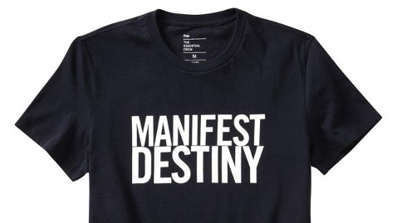
Gap
Gap has pulled from its shelves a black and white T-shirt printed with “Manifest Destiny” across the chest, after backlash from consumers who say the slogan is racist toward Native Americans.

When the item first went on sale about a month ago as part of Gap’s GQ collection, people quickly took to social media, expressing their outrage. In addition to Facebook messages and plenty of email, a petition was created on Change.org, amassing more than 5,000 followers.

“This article of clothing promotes a belief that has resulted in the mass genocide of indigenous people, and it serves to normalize oppression,” the petition read. “This shirt is marketed to teens and young adults, and it gives no context for the racism and inequality that persists in our society, to this day, as a result of this doctrine. We are asking that this shirt be discontinued, and that an apology be issued.”

The “Manifest Destiny” phrase was first used by newspaper editor John O’Sullivan in 1845 to justify U.S. expansion into the West during the 19th century amid the Second Great Awakening when many settlers believed God had blessed their expansion over the whole nation. “That claim is by the right of our manifest destiny to overspread and to possess the whole of the continent which Providence has given us for the development of the great experiment of liberty and federated self-government entrusted to us,” he wrote.

A Native American activist, Renee Roman Nose, sent a letter to Gap, which was also published in Indian Country Today, explaining her distaste for the shirt. “Manifest Destiny was the catchphrase which led to the genocide of millions of my people, millions of Indigenous people throughout this country,” Nose wrote. “I am also inviting the more than 1,700 people on my Facebook page to boycott your stores and inviting them to shop with their conscience.”
The shirt’s designer, the iconic fashion designer Mark McNairy, took to Twitter to, at first, boast about the slogan. “MANIFEST DESTINY. SURVIVAL OF THE FITTEST,” he wrote, then later deleted.

He followed up Oct. 15 with another tweet personally apologizing for his dismissal of what many believe to be a dark time in American history. “I AM SORRY FOR MY SURVIVAL OF THE FITTEST COMMENT. IT HURT ME DEEPLY TO BE CALLED A RACIST AS THAT IS NOT ME. I REACTED WITHOUT THINKING,” he tweeted in all caps.

Gap issued a statement Tuesday, one day after McNairy’s tweet, in response to the backlash. “Thank you for your feedback regarding the “Manifest Destiny” t-shirt,” the company said. “Based on customer feedback, we will no longer offer the t-shirt in our stores or online.”

