Progressive Reform Assignment
Your task: (50 POINTS!!!)
Our society has fallen into the depths of despair. We must expose, to the public, the many social injustices that inflict our nation so that we can initiate reform. Our next publication is critical, we need to include compelling stories that will create public outrage, bringing attention to these issues. I have compiled a list of stories that I want you to cover:
*Tenement Housing (poverty): Jacob Riis
*Public Health (Meat Packing Industry) : Upton Sinclair
*Child Labor: John Spargo
*Big Business (Monopolies) : Ida Tarbell
*Prohibition (Alcohol) : Women’s Christian Temperance Union
*Immigrants: Jane Adams
*Racial Segregation: W.E.B. Du Bois
*Government corruption : Thomas Nast
Assume the role of ONE of the above progressives and the social issue they championed. You will then investigate this person, the issue they fought for, their efforts, and their successes. After conducting your research you must present your findings in an eye-catching powerpoint (5-7 slides). The presentation must include the following:
  - Explanation of the social ill you are reporting on.
    - Who does it affect? Why must it be changed? Expose all the negatives you can! (IN YOUR OWN WORDS!)
  - A short biography of the progressivist you have become
    - Who are they? Background on life story? Why are they interested in this topic? (IN YOUR OWN WORDS)
  - At least 3 photographs that help persuade your readers
  - One political cartoon, chart or graph that solidifies your argument.
  - Proposed solution (IN YOUR OWN WORDS)
    - What laws should be passed (or were passed) to help fix this problem?
    - What efforts should be made to fix the problem?
  - Resources
    - A list of your sources – What websites did you use?
**Remember, your quality and efforts are meant to persuade Americans to take action! And your grade will reflect it as well!**
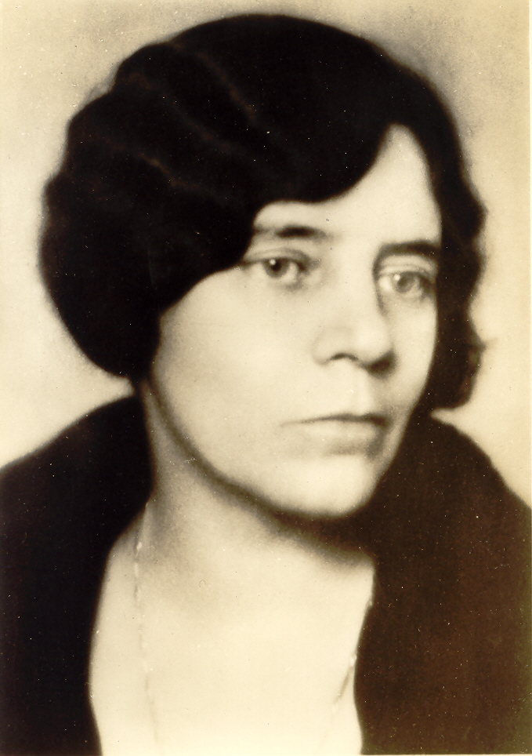
Alice Paul

The Declaration of Independence claims all men are created equal, and yet women have repeatedly been treated as second class citizens. For nearly a century, women have patiently waited for the doors of democracy to open with no success! Women are not allowed to vote, women are not given a political voice and we are tired of taking a back seat. Women deserve the same rights and opportunities as any male citizen!

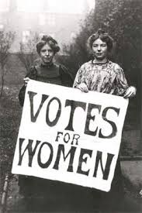
Biography:
Alice Paul’s Quaker background had a huge impact on her suffrage beliefs. Quakers believe in absolute equality and a dedication to spiritual improvement. For Paul, her concern was suffrage.
After graduating from college, she joined a Social and Political Union in England – the very first suffragettes. It was there that she gained a fearless ability to face confrontation including prison, hunger strikes and force feeding.
Upon arriving back in the United States, she began her American suffrage campaign and used many of the same tactics to help her push the suffrage movement ahead!

